Review of the Specifics for Framework Based Projects
By Dmitri Ilkaev

Abstract
The focus of this paper is to present an analysis of framework based projects, their specific characteristics and life cycle, and main design principles for such projects. We also describe a sound approach to the project estimates. We believe that the outlined approach and discussed specifics will be helpful for the development teams busy with the implementation of the framework based software systems.

Introduction
There is a lot of attention in the industry focused on project using popular categories of system development/integration approaches. These include: custom development, where design and development are done from the scratch, which would include Rational Unified Process (RUP) initiatives; and Commercial Off-The-Shelf (COTS) product implementations, for which EPIC (Evolutionary Process for Integrating COTS-based systems) together with the special COTS plug in for RUP play well for the second category of projects (see [1-4]).
Much less attention is being paid to framework based projects. In this context we are not focusing on lower level frameworks like Spring, Espresso, etc. (or any other development framework in .NET or J2EE platforms which a lot of companies develop in house for their own rapid application development needs). We are addressing the collection of the predefined business components, with some relationships between them, and implemented (completely or partly) business logic and workflow linking these components together.
The type of framework is typically the collection of services which act as templates for the development of a new system, with pre-designed components based on common business rules. It also includes a variety of subcomponents that allow you to pick and choose which functions that are most important to your stakeholders, giving increased ability to adapt to changes in the business environment resulting from process improvement, and/or regulatory or legislative mandates.
Such frameworks represent a relatively new phenomenon in the Information Technology (IT) market for the development of business applications. Their appearance is driven mainly by the fact that it is impossible to achieve the level of configurability in the COTS products to the degree necessary to reflect specific and unique client requirements in a multiple market sectors.
An example of one such framework is Curam. Their social enterprise framework includes human services, labor, health, social security and pensions. Our company, Tier Technologies, focuses on a public sector, and manages projects in a multiple verticals including Pension Administration, Child Support Enforcement, and Unemployment Insurance (UI). For UI space Tier had developed its own framework called UI Connect. Other players in this space have implemented similar offerings, such as: uFACTS (Bearing Point), eTABS (Covansys), etc.
This article will mainly focus on the specifics of framework based development primarily in a public sector, its differences from COTS projects, as well as, the approach to correctly estimate the effort required for this type of projects.

Specifics of COTS based projects
Building solutions based on existing COTS packages is different from typical custom development in that the COTS packages are not designed to meet the specific requirements of an individual project. This results in the need to have a significant understanding of the COTS package functionality and potential evolution of the product in order to effectively identify the gaps between the stated requirements and associated business processes, and the “out-of-the-box” solution”., which then drive the resulting architecture. When building solutions based on COTS packages, it is important to simultaneously define and tradeoff among the four spheres of influence as defined by EPIC.
The core of the approach is to keep a balance between the four spheres of influence throughout the life of a project. The four spheres represent competing interests that must be considered in forming a viable solution that effectively leverages existing COTS packages. (See figure 1)
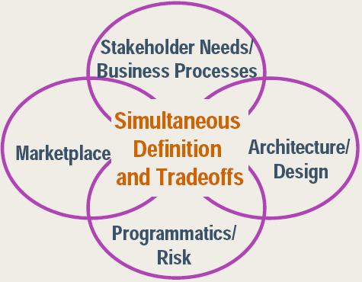

Figure 1: Four Spheres of Influence

The four spheres of influence are:
Sphere 1 - Stakeholder Needs and Business Processes - denotes requirements (including availability, performance, security, etc.), business processes, key business drivers, and operational environment.
Sphere 2 - Architecture and Design - addresses the essential elements of the system, the relationships between them, and how they fit with the enterprise system. The elements include: structure, behavior, usage, functionality, performance, availability, reuse, standards, configuration, constraints, etc...
Sphere 3 – Marketplace – indicates available and emerging COTS technologies and products, the available items, and relevant standards.
Sphere 4 - Programmatic and Risk - denotes the management aspects of a project. These include the costs, schedule, and risk of building, deploying, and supporting the proposed solution. Key to the management factors are the tradeoffs (cost, schedule and risk) of either changing the business processes or making necessary changes in the base architecture.
These four spheres are continuously refined and rebalanced through the life of the project, as a decision in one sphere will inform and likely constrain the decisions that can be made in another sphere.
The RUP Plug in for COTS performs detailed mapping of these spheres on influence against a typical project life cycle, which results in potential adjustments in the scope for each phases of the project. (See figure 2)

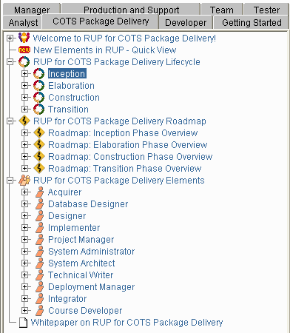

Figure 2: Main Menu of the COTS Plug in for RUP

Specifics of a Framework Based Projects
Again, the definition of a framework is a collection of business components, converted in a working system, covering a relatively high percent of the base functionality required for the selected market segment or business application area. This framework is normally built using common industry standards and protocols, based on the open architecture, and come with the set of tools and/or procedures showing how to modify or extend the functionality provided by the framework.
Tier Technologies, being focused on a public sector, has developed its own framework. In Unemployment Insurance (UI) space, this framework is called UI Connect. Main observation and findings in the paper are coming as the results of our work on design and implementation of this framework and performing comparative analysis of another frameworks and associated projects.
Using this definition for framework automatically impacts the four spheres of influence. First, the market space for a business vertical specific frameworks is very limited, especially in the public sector, where the business, functional, and technical requirements for State-wide, enterprise class systems can vary significantly from State to State. Normally the vendor who developed the initial framework will also be the vendor contracted to use that framework to build the new system based on the specific requirements of the client State or other government entity.
Vendor selection is determined using a Request for Proposal (RFP) process. This process maps the vendor submitted proposals against an extensive selection criteria that is define by the contracting organization to ensure objective in the decision-making. This criterion addresses compliance with the stated requirements, organizational and team qualifications, costs, and schedules to make the determination of which vendor will develop and implement the needed system. Once RFP is awarded, the importance of the marketplace in relation to the specific project becomes less important, unless the project fails, at which point a new RFP may be introduced.
On the other hand, three other spheres, their interactions and overlaps become even more important. Architecture and Design become critical factors in determining project success. This is because the framework only partly covers the functional and technical requirements, resulting in a significant design and development efforts to ensure complete coverage of the stated requirements. These design and development efforts define the programmatics and associated risks, while trying to manage the project, define the logistics of each project phase, and determine specifics of the implementation. Stakeholder needs and business processes are in on-going interaction with the other two spheres. Needs and processes drive technical design and implementation, while certain technology limitations or specifics may change the flow of business processes. (See figure 3)

Figure 3: Three Spheres of Influence for a Framework Based Projects

This growing overlap between the three spheres includes an increasingly detailed understanding of the following:
- Negotiated and prioritized stakeholder needs and end-user business processes.
- Architectural alternatives and integration mechanisms that bind the components together.
- Implications of the components on the stakeholder needs, the end-user business processes, and the solution architecture planning necessary to implement and deploy the solution; including any needed end-user business changes, the associated impact to cost, schedule, and risks.
Table 1 summarizes specifics of COTS based projects outlined by EPIC, and shows the differences for the framework based projects (FBP).
Table 1: RUP Refinements for COTS and Framework Based Projects
Refined RUP Workflows for COTS | Framework Based Projects Refinement
Requirements must stay fluid until the component implications are understood–often until well within the Elaboration Phase. | Same.
Analysis and design activities must start sooner–in parallel with the requirements activities. | Same. There is even more analysis and design efforts, since frameworks generally have only partial coverage (less then COTS) against project requirements.
The project management activities include the management of vendor/supplier relationships. | Limited especially when project is rewarded and the framework vendor itself drives the project implementation.
Business modeling is mandatory rather than optional. | Same. This is even more critical with frameworks, as a result of the limited coverage provided by the framework.
Activities are added to monitor the marketplace and evaluate candidate components. | Limited or non-existent.
Business, contracting, and organizational change activities are integrated throughout. | Same or less is required.
The Lifecycle Objectives (LCO) anchor point has been redefined to allow multiple candidate solutions to proceed to the Elaboration Phase. | This would not happen in a majority of situations with a framework.
Iterations are more chaotic to allow for simultaneous gathering and refining of information in all four spheres. | Iterations are more structured and organized due to the larger overlap between remaining three spheres and due to the fact that the project is closer to the custom development.
An experimentation facility is essential across all phases to evaluate new and changed components in the context of the evolving solution. | Even more important for the framework since developers need to know it inside and out before being able to modify and/or enhance it.

Once the specifics of the framework based projects are identified, they follow the same roadmap as defined in the RUP phases, RUP iterations, and EPIC principles in the manner similar to the one shown in figure 4.
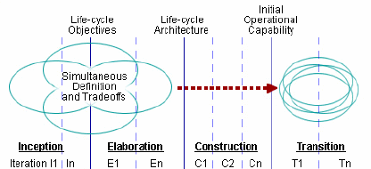

Figure 4: Project Dynamics Based on RUP and EPIC
An iterative development process is necessary to keep the requirements and architecture in synch as the three spheres of influence are considered and adjusted in order to elaborate on, and enhance, the available or selected business components framework.
Each of the iterations contains activities that gather information from each of the three spheres. Each iteration then refines the newly gathered information through analysis and negotiation with affected stakeholders to form the uniform detailed understanding needed to design modifications to the existing framework. All of which should result in the working system, supporting the organizations defined business processes. The iterations are defined through the four RUP phases and associated milestones and managed by the constructed project plan based on the detailed functional and technical analysis and design for each set of tasks and iterations.
While the project software development life cycle follows combined RUP and EPIC principles tailored for the framework specifics, the design approach normally follows ARAD (Architectured Rapid Application Development). The formal ARAD definition is illustrated in figure 5 (see [5]).

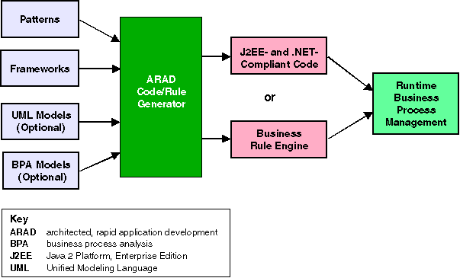
Figure 5: ARAD Definition

In the ARAD based design process we have an extra required step: comparing a new use cases generated out of the current project requirements against base use cases which had been used for the initial framework development. A gap analysis of the use cases needs to be performed, which likely will initiate work on the additional use cases and resulting technical design artifacts to cover any discovered gap. (See figure 6 for a graphic depicting the use case gap analysis process)

Figure 6: Use Cases Gap Analysis

It is beneficial to include a business rules engine into the framework itself to separate framework components, and their wiring, from the configurable rules on how these components work together. Additional design efforts are needed to extract the required business rules, which are formalized into a structure such as decision trees, spreadsheet type tables, formulas, etc. The separation of business rules from the rest of the components significantly improves flexibility of the overall solution in all functional areas and technical layers of the architecture.
With the specifics of the framework based projects is identified, it is not important to discuss how these types of projects should be estimated.

Estimate Model for Framework Based Projects
After assessing multiple estimate models, such as those based on the number of software lines of code, functional points, Internet points, etc.; the best and optimal model for the framework based projects would be to determine estimates established with use case points. All of other methods imply serious limitations or uncertainly in their definitions and/or model parameters. For example, an effective number of lines of code can be calculated based on the following formula: Effective SLOC = SLOC*(AA+ SU+ 0.4*DM+0.3*CM+0.3*IT)/100, where SLOC here is the number of lines of reusable code which will be modified. DM is the percentage of design modified, CM is the percentage of the code that is modified, IT is the percentage of the original integration effort required for integrating the reused software. SU is a factor based on the cost of software understanding ?, AA is a factor which reflects the initial assessment costs of deciding if software may be reused. This formula is used by many commercial software estimate tools. However it is important to note that the model parameters used in the formula need to be estimated as well. In addition, the formula requires a detailed knowledge on the number of lines of code specific to each of the estimated module or part of the functionality.
In the large and complex software projects a change in one component results in multiple changes in other components of the software. In order to estimate such impacts the structural analysis of the code was used with the task to identify the average number of dependencies and dependents associated with a component of a framework and so-called “Affect of Average”. This shows an average number of surrounding components affected by a change in one component. All these estimates are valid and produce meaningful and useful information. That being said, the model is quite complex and difficult to use.
The use case based model fits nicely into the roadmap established by RUP and ARAD. Once the gap analysis has been performed, as previously discussed; potential new use cases, reused use cases, and use cases to be modified will be identified in order to build the solution on the top of the existing framework.
A brief outline of the recommended model is presented below. An assessment of the use cases is performed to define the degrees of complexity. Then the total number of a Unique Use Case Points (UUCP) can be calculated as the sum of the use cases weighted by a complexity factors (UUCW – unadjusted use case weights) and the sum of the actors in the use cases weighted by their complexity factors (UAW – unadjusted actor weights), so UUCP=UUCW+UAW.
Another alternative way of defining use case complexity is the use of 5/10/15 factors for the easy, average and complex use cases respectively (this approach, for example is used in the Enterprise Architect from Sparx Systems)
The number of Use Case Points UCP = UUCP * TCF * ECF, with Technical Complexity (TCF) and Environmental Complexity (ECF) defined below. With the Estimated Hours per UUCP (HRS) set as some of the model parameter, the total efforts for the implementation of the selected use cases are: Total Hours (HRS * UCP).
Here is the definition of the complexity factors and their typical values:

Metric | Description | Weight | Value | TCF
TCF01 | Distributed System | 2.00 | 5.00 | 10.00
TCF02 | Response or throughput performance objectives | 1.00 | 4.00 | 4.00
TCF03 | End user efficiency (online) | 1.00 | 2.00 | 2.00
TCF04 | Complex internal processing | 1.00 | 4.00 | 4.00
TCF05 | Code must be re-usable | 1.00 | 2.00 | 2.00
TCF06 | Easy to install | 0.50 | 5.00 | 2.50
TCF07 | Easy to use | 0.50 | 3.00 | 1.50
TCF08 | Portable | 2.00 | 3.00 | 6.00
TCF09 | Easy to change | 1.00 | 3.00 | 3.00
TCF010 | Concurrent | 1.00 | 2.00 | 2.00
TCF011 | Include special security features | 1.00 | 2.00 | 2.00
TCF012 | Provide direct access for third parties | 1.00 | 5.00 | 5.00
TCF013 | Special user training facilities are required | 1.00 | 3.00 | 3.00
 |  |  | Total: | 47.0

Factor | Value
Unadjusted TCF value (UTV) | 47.00
TCF Weighting (TWF) | 0.01
TCF Constant (TC) | 0.60
Technical Complexity Factor (TCF) = TC + (UTV * TWF) | 1.07

Metric | Description | Weight | Value | ECF
ECF01 | Familiar with Rational Unified Process | 1.50 | 4.00 | 6.00
ECF02 | Application experience | 0.50 | 3.00 | 1.50
ECF03 | Object-oriented experience | 1.00 | 4.00 | 4.00
ECF04 | Lead analyst capability | 0.50 | 4.00 | 2.00
ECF05 | Motivation | 1.00 | 3.00 | 3.00
ECF06 | Stable requirements | 2.00 | 4.00 | 8.00
ECF07 | Part-time workers | -1.00 | 0.00 | 0.00
ECF08 | Difficult programming language | -1.00 | 3.00 | -3.00
 |  |  | Total: | 21.50

Factor | Value
Unadjusted ECF value (UEV) | 21.50
ECF Weighting (EWF) | -0.03
ECF Constant (EC) | 1.40
Environmental Complexity Factor (ECF) = EC + (UEV * EWF) | 0.75

Exact weights and values are the subjects of the model, specific framework, and other conditions. To improve the accuracy of the model they should be periodically re-calibrated. A discussion of the exact values used in our model is outside the scope of this paper, however, the industry standard parameters are known and published elsewhere. The different nature of use cases and actors can be addressed by adjustment to their complexity factors, which result in the change of the effective number of the unique use case points.
There are three types of use cases which will be involved in the project lifecycle:
- New
- Old (reused without any modifications)
- Adapted (framework use cases which need to be modified/enhanced to address the new project requirements)
The new use cases are the subject of the standard estimates, described above, while an old use cases will still require some additional work on their testing. This is in combination with the new and adapted use cases and adapted use cases that will require additional assessment, redesign, and implementation efforts to add more of the newly required functions. In order to account for the extra efforts, the introduction of two additional adjustment parameters to the weighting factors is needed.
In this way an effective weighting factor for the reused use case is calculated as effective W = W + TW, where W is the original weight and TW (testing weight, accounts for additional testing and integration efforts required for integrating the reused use cases and respective software modules) and effective weight for the adapted use cases is calculated as: effective W = W + MW, where W is the original weight and MW (modification weight, which accounts for an extra assessment, design, coding and implementation efforts). Both TW and MW can have values within 1-3 range when using a weighting factor, or within 5-15 range when following simplified 5/10/15 approach for use case weighting. As one can see, these adjustments for the reused and adapted use cases can address a number of different scenarios, (for example by just changing as effective complexities of the use cases).
The use case points based estimates are very easy to use, (an Excel spreadsheet with the base for estimates can be created within an hour or less), with all model parameters having clear business or technical meanings, and is easily justified.
Since the framework itself, (UI Connect in Tier’s case), is not a static solution, but a set of technical modules being applied under the process of optimization and enhancements, and during the framework modifications and associated analysis (including use case design); sufficient factorial material will have been collected to adjust the model and prove its validity.

Conclusion
This paper reviewed the specifics of the COTS and framework based projects and how they follow modified RUP and EPIC methodologies. It proposes three main spheres of influence:
- Stakeholder needs and business processes
- Architecture and design
- Programmatic and risks
Their increasing overlap through the life cycle of the project will define the project dynamics, phases, and iterations.
While the project life cycle is described by the evolution of the overlaps between the three spheres of influence, the design approach for framework based projects will follow the ARAD (Architectured Rapid Application Development) principles. Additionally, the gap analysis between the use cases being used for framework construction, and the use cases driven by the project’s functional and technical requirements, is an essential activity which defines the scope of the new project.
For framework based project estimates the standard use case point’s model is proposed. This includes three categories of use cases:
- New
- Reused (existing framework use cases being used as is)
- Adapted (existing framework use cases being modified based on the functional and technical requirements of the project)
This estimate includes the introduction adjustment parameters to account for the integration and test efforts for reused cases, as well as, assessment, redesign, and other activities associated with the implementation of the adapted use cases.
Together, this paper presented an analysis of framework based projects, their specifics and life cycle, described main design principles, and illustrated the sound approach to the estimates of this type of the projects. The outlined approach, and discussed specifics, will be helpful for development teams busy with the implementation of the framework based software systems.

References
1. Cecilia Albert and Lisa Brownsword. Evolutionary Process for Integrating COTS-Based Systems (EPIC): An Overview. Key Elements in Building, Fielding, and Supporting Commercial-off-the-Shelf (COTS) Based Solutions. TECHNICAL REPORT, CMU/SEI-2002-TR-009, ESC-TR-2002-009, July 2002.
2. Cecilia Albert and Lisa Brownsword. Evolutionary Process for Integrating COTS-Based Systems (EPIC). Building, Fielding, and Supporting Commercial-off-the-Shelf (COTS) Based Solutions. TECHNICAL REPORT, CMU/SEI-2002-TR-005, ESC-TR-2002-005, November 2002.
3. Ronald Chan Adopting RUP in a COTS implementation project Part I: Getting started; Rational Edge May 2003
4. Cécile Péraire and Russell Pannone RUP for COTS Package Delivery Roadmap Rational Software, IBM Software Group
5. Michael J. Blechar, Matthew Hotle Gartner Report: ARAD Methods and Tools Improve Productivity and ROI 11 October 2004
http://mediaproducts.gartner.com/reprints/compuware/article1/article1.html

